**A PBL Report**

**of**

**“Game Development”**

**in**

**“War League”**

**Submitted to**



**SAGE UNIVERSITY**

**BHOPAL (M.P.)**

**Submitted by Under the supervision of**

**Vedant Kurchania Lokesh Sahu**

**Kanishk Shrotriya Prof. (Guide)**

**Aditya Nair**

**SCHOOL OF COMPUTER APPLICATION**

**SAGE UNIVERSITY, BHOPAL (2022-23)**

**SANJEEV AGRAWAL GLOBAL EDUCATIONAL UNIVERSITY, Bhopal**

**SCHOOL OF ADVANCE COMPUTING**

**DECLARATION**

I **Student Name** student of “**Bachelor of Computer Application in Cloud Computing”,** session **2022-23,** hereby informed that the work presented in this project entitled **“Project Title”** is the outcome of my own work, is a Bonafede and correct to the best of my knowledge and work has been carried out taking care of ethics. The work presented does not infringe any patented work and has not been submitted to any other University or anywhere else.

**Date: 6/2/2023 Student Name**

**Place: Bhopal Vedant Kurchania Kanishk Shrotriya**

**Aditya Nair**

**Supervisor Dean/HOS**

**Prof. Lokesh Sahu (Guide)**

**(Bhopal)**

  **SANJEEV AGRAWAL GLOBAL EDUCATIONAL UNIVERSITY, Bhopal**

**SCHOOL OF ADVANCE COMPUTING**

**CERTIFICATE**

This is to certify that the work embodies in this project entitled “**War League”** being submitted by **Vedant Kurchania, Aditya Nair and Kanishk Shrotriya** in partial fulfillment of the requirement for the award of **“Bachelor of Computer Application in Cloud Computing”** to Sage University, Bhopal (M.P) during the academic year **2022-23** is a record of Bonafede piece of work, carried out by her/his under my supervision and guidance in the **School of Computer Application, SAGE Bhopal.**

**Supervisor HOS**

**Prof. Lokesh Sahu (Guide) Dr. Pinaki Ghosh**

**SSOCA, Bhopal SSOCA, Bhopal**

 **SANJEEV AGRAWAL GLOBAL EDUCATIONAL UNIVERSITY, BHOPAL**

**SCHOOL OF ADVANCE COMPUTING**

**DECLARATION OF PLAGIARISM**

I hereby declare that the work embodies in this project entitled **“War League”** being submitted by, **Vedant Kurchania, Aditya Nair and Kanishk Shrotriya** of **“Bachelor of Computer Application in Cloud Computing”** in **SCHOOL OF COMPUTER APPLICATION**, Bhopal, is an authentic record of my own work carried under the supervision and guidance of **Prof.** and has not been submitted anywhere.

I also declare that “A check for Plagiarism has been carried out on this project report and is found within the accepted limit and report of which is enclosed as annexure I”.

**Student Name**

**Supervisor Vedant Kurchania**

**Kanishk Shrotriya Prof. Lokesh Sahu (Guide)**

**Aditya Nair**

**SAGE, Bhopal**

**(School of Computer Application, Bhopal)**

**HOS/Dean Signature**

**SANJEEV AGRAWAL GLOBAL EDUCATIONAL UNIVERSITY, Bhopal**

**SCHOOL OF ADVANCE COMPUTING**

**CERTIFICATE OF APPROVAL**

The project entitled **“War League”** being submitted by **Vedant Kurchania, Aditya Nair and Kanishk Shrotriya** has been examined by us and is hereby approved for the partial fulfillment for the award of **“Bachelor of Computer Application in Cloud Computing”** for which it has been submitted. It is understood that by this approval the undersigned do not necessary endorse or approve any statement made, opinion expressed or conclusion drawn therein but approved the project only for the purpose for which it has been submitted.

**(Internal Examiner) (External Examiner)**

**Prof. (Guide)**

**(SSOCA, SAGE, Bhopal)**

  
**SANJEEV AGRAWAL GLOBAL EDUCATIONAL UNIVERSITY, Bhopal**

**SCHOOL OF ADVANCE COMPUTING**

**ACKNOWLEDGEMENT**

It is my proud privilege to present a project on **“War League”**. I take this opportunity to express deep sense of gratitude and would like to give thanks to my guide, **Prof. XYZ Bachelor of Computer Application in Cloud Computing**, Bhopal, for their valuable guidance, inspiration and encouragement that has led to successful completion of this work. I would like to express my heartfelt thanks towards HOS, Dr. Pinaki Ghosh . I would like to express my heartfelt thanks to Dr. Gaurav Shrivastava for their valuable suggestions throughout the project work. I could not have accomplished, what I actually have, without their guidance.

I would like to express my heartfelt thanks and sense of gratitude to **Lokesh Sahu** for being a constant source of inspiration. I am also thankful to all faculty members and staff of SSOCA for their suggestion and support.

I would like to deeply thank my family and friends for all the support and encouragement they have rendered time to time.

Last but not the least, I dedicate my work to almighty God without whose wish and helping hands this work would not have taken the shape it has now and also to my family members whose support and encouragement had led me to complete this task.

**TABLE OF CONTENTS**

**LIST OF FIGURES**

|  |  |  |
| --- | --- | --- |
| **S. No.** | **Title** | **Page No.** |

**LIST OF TABLES**

|  |  |  |
| --- | --- | --- |
| **S.No.** | **Title** | **Page No.** |

|  |  |  |
| --- | --- | --- |
| **S. No** | **Title** | **Page No** |
| **1.** | **INTRODUCTION** |  |
| **2.** | **LITERATURE SURVEY** |  |
| **4.** | **OBJECTIVE & MOTIVATION** |  |
| **5.** | **PROBLEM IDEFINITION & PROPOSED WORK** |  |
| **6.** | **IMPLEMENTATION & RESULT ANALYSIS** |  |
| **7.** | **CONCLUSION AND FUTURE WORK** |  |
| **8.** | **REFERENCE** |  |
| **9.** | **PLAGIARISM REPORT (Annexure-I)** |  |

**INTRODUCTION**

Tactical 4 vs 4 Shooter combat stylized in FPP (First Person Perspective) in a decent themed map.

* FPP, Indie, Shooter, Low Poly, Competitive, Tactical.
* To play a low poly, FPP shooting game on minimum requirements system.
* Any person with stable internet and i5 system, no **DGPU required.**

**LITERATURE SURVEY**

**There are many games in this genre but they aim for a good system as they are CPU and GPU centric and most of them are connected on internet servers because of that, Ping always fluctuates and also we need a proper net connectivity to play seamlessly.**

**Games Like:**

* **Valorant, CSGO, KRUNKER.IO**
* **High Requirement System is not required, LAN CONNECTIVITY No Global server required as we can connect with LAN / IP address.**

**OBJECTIVE & MOTIVATION**

**Objective**

**To provide a fun immersive gameplay in a low budget system so we can play with friends or anyone. Also, we can play it offline or online (with LAN Connectivity).**

**Motivation**

**Motivation came as I learned C# coding and game Designing courses on Unity Platform and wondered why shouldn’t I make my own game?**

**PROBLEM IDEFINITION & PROPOSED WORK**

**As we have tested other same games in this genre, we observed that they are mostly P2W (Pay To Win) as you have to purchase for enjoying the full game, Requires a good system with Internet.**

**So in our project we have eliminated both of these problems as it will be free anyone can play full game and will work on any system.**

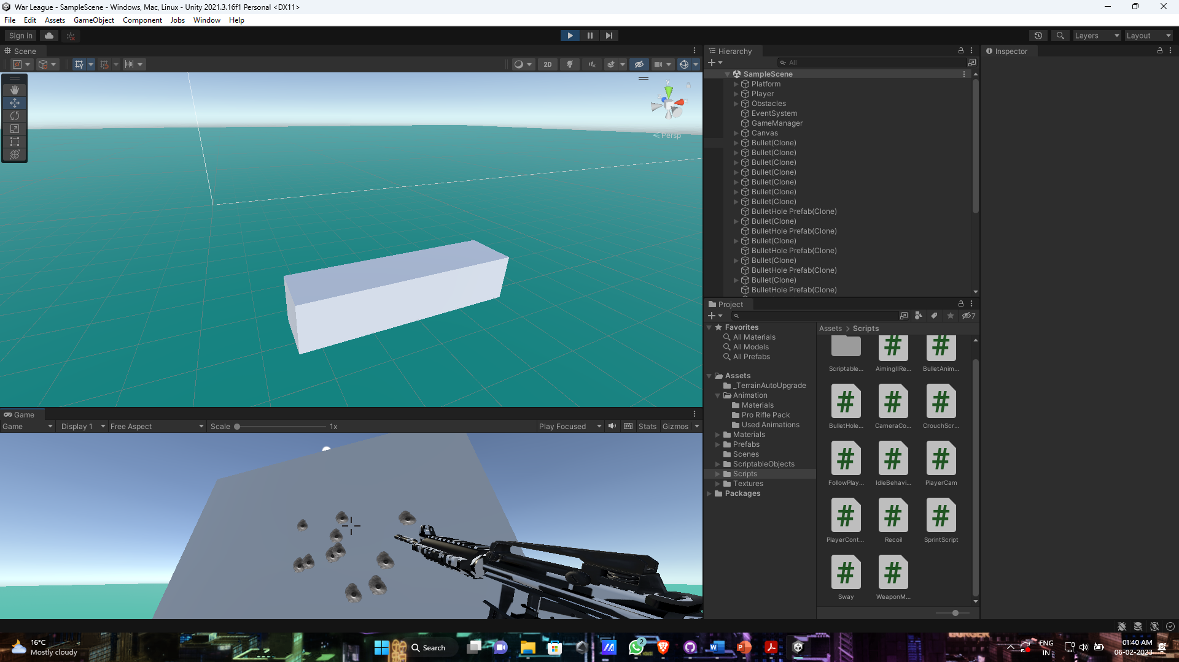

**IMPLEMENTATION & RESULT ANALYSIS**

**Implementation is simple. We will create our game on Unity Engine by applying Unity Assets, C# Scripting, etc. We also require other software’s for Character Designing, Rigging, Sounds, Models and Textures.**

* **System/User requirements: Minimum: i3 – 7200U, Intel UHD Graphics 600, Around 3-5 Gb HDD space required.**

**Recommended: i5 – 9th GEN, Nvidia GTX 800, SSD will be better.**

**\*Stable Internet Connectivity Required*.**

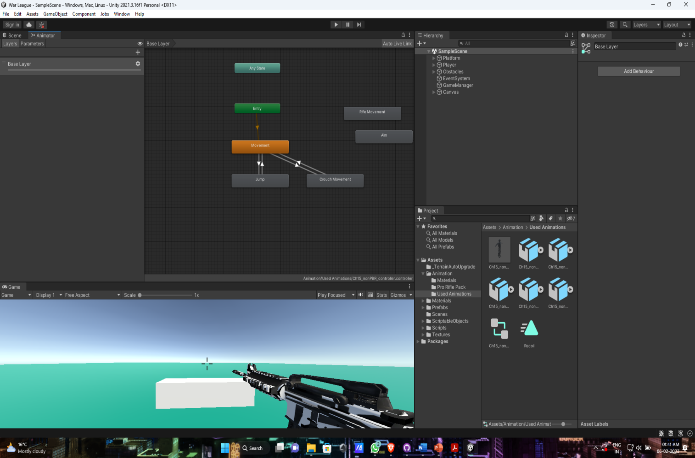

**CONCLUSION AND FUTURE WORK**

**Conclusion**

**In this project, it will be low violence, Easy to understand Mechanism and Low system Requirements needed.**

**Players can be able to play FPP shooting game on old pcs without lag.**

**Future Work**

**We will add new Characters, Dynamic Environment, New Map, Various elements like Sounds, SFX, Bugs and glitch Fixes and many more updates in the future.**

**REFERENCES**

* **https://unity.com/**
* **https://www.blender.org/**
* **https://www.mixamo.com/**
* **https://www.adobe.com/in/products/indesign**
* **https://www.adobe.com/in/products/indesign.html?**
* **https://www.adobe.com/in/products/character-animator.html**

**PLAGIARISM REPORT (Annexure-I)**

